**Task 2 – [Web App] Seating Arrangement System**

The school would like to implement an online seating arrangement system for class and subjects. In this task, you are required to implement a prototype using normalised database and flask web application to manage these records.

Please save all your files inside the Task 2 folder.

The following information of each Student is stored:

MatricNo – unique string in the format of "RVHS-YYYY-XXX" where YYYY is the year of entry to school and XXX is a 3-digit string ranged from "001" to "999".

Name – name of student

Class – class of student

IndexNo – index number of the student in the class

Gender – gender of student, to be stored as a single character, using either "M" or "F"

The following information of each ClassGroup is stored:

ClassGroupID – unique autoincrement integer to identify the class group

ClassGroupName – name of the class group, e.g. "Computing"

Venue – name of venue for this class group, e.g. "4A Classroom", "iCode Lab"

The following information of each SCR (Student-ClassGroup-Relationship) is stored:

MatricNo – matric number of the student

ClassGroupID – id of the class group

The information is to be stored in three tables:

Student

ClassGroup

SCR

**Task 2.1**

Create an SQL file called Task2_1.sql to show the SQL code to create the database seating.db with the three tables.

The table Student must use MatricNo as its primary key, and the table ClassGroup must use ClassGroupID as its primary key. The table SCR should use MatricNo and ClassGroupID as a composite key, while MatricNo and ClassGroupID must refer to MatricNo in Student and ClassGroupID in ClassGroup as foreign keys.

Save your SQL code as

Task2_1.sql

[5]

**Task 2.2**

The files students.csv, classgroups.csv and scr.csv contains information about the student, class groups and the Student-ClassGroup-Relationships. The first row of each file contains the header of the respective columns. Each row in the files is a comma-separated list of information.

Write a Python program to insert all information from the three files into the database seating.db. Run the program.

Save your program code as

Task2_2.py [5]

**Task 2.3**

A teacher would like to generate the class list of classgroup with the **ClassGroupName** **"Comp_4AB"**. Query and display a list of data with the following fields as shown in the table, sorted in the **ascending** order according to **Class**, followed by **IndexNo** of the student.

|  |  |  |  |
| --- | --- | --- | --- |
| Class | IndexNo | Name | ClassGroupName |
| … | … | … | … |

Write the SQL code required.

Save this code as

Task2_3.sql [6]

**Task 2.4**

The school wants to implement a function where teachers can enter the ClassGroupName and the system will generate the seating arrangement based on class and index number of students.

Write a Python program and the necessary files to create a web application that:

* Receive the ClassGroupName from a HTML form, then,
* Creates and returns a HTML document that enables the browser to display (students class(index), name) in a table format. As shown in this image:

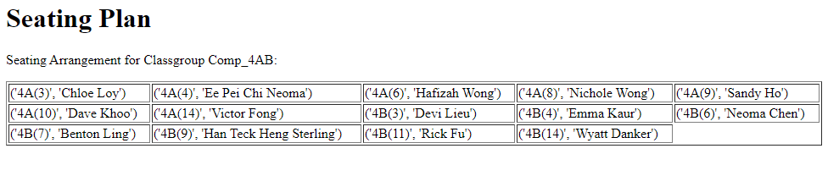

You may assume:

* Table have 5 columns
* Each row starts from the left hand side
* All inputs are valid

Save your program as

Task2_4.py

With additional files or sub-folders as needed in a folder named

Task2_4

Run the web application. Enter the following ClassGroupName:

"Comp_4AB"

Then save the output of the program as Task2_4.html.

[14]

**Task 2.5 [Bonus]**

Lastly, if you would like to challenge yourself, copy paste your files from folder Task2_4 to a new folder named Task2_5.

Attempt to modify your code to suit the following needs:

1. Search form can allow user to specify number of columns.
2. Snake shape with odd rows starting from left, even rows starting from right.
3. Use css style to display the data in the following format.

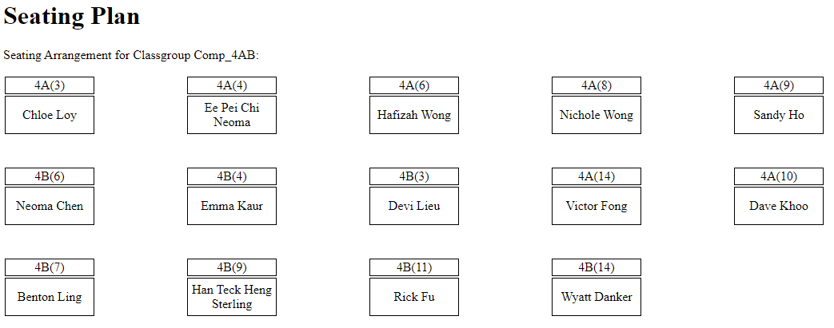

[2]

**[End of Paper]**